**Business Requirement:**

Develop an Uploader by using which you can upload Master data on any Z or Y table (Custom Table).

---------------------------------------------------------------------------------

**Program Name : ZR_MASTER_DATA_UPLOAD**

**Description: Uploading data into custom( Z ) table from Excel**

* ---------------------------------------------------------------------------------------------------------
* *\*&---------------------------------------------------------------------\**  
  *\*& Report ZR_MASTER_DATA_UPLOAD*  
  *\*&---------------------------------------------------------------------\**  
  *\*&*  
  *\*&---------------------------------------------------------------------\**  
  REPORT zr_master_data_upload.  
  *\*TABLES : zmm_vend_grp.*  
  *\*DATA:it_final TYPE STANDARD TABLE OF zmm_vend_grp,*  
  *\*     wa_final TYPE LINE OF it_final.*  
  DATA:lt_excel       TYPE TABLE OF alsmex_tabline,  
       lt_dref        TYPE REF TO data,  
       ls_dref        TYPE REF TO data,  
       lv_col         TYPE i,  
       lo_alv         TYPE REF TO cl_salv_table,  
       lt_table_filds TYPE TABLE OF dfies.  
  *\*\*\* --- Field Symbols*  
  FIELD-SYMBOLS : <fs_table> TYPE any .  
  FIELD-SYMBOLS : <ft_table> TYPE STANDARD TABLE.  
  FIELD-SYMBOLS : <dyn_field> .  
    
  *\*\*\* --- Selection screen designing*  
  SELECTION-SCREEN BEGIN OF BLOCK b1 WITH FRAME TITLE TEXT-001.  
  PARAMETERS:p_file  TYPE rlgrap-filename OBLIGATORY,  
             p_table TYPE dd02l-tabname OBLIGATORY,  
             p_test  AS CHECKBOX DEFAULT abap_true.  
  SELECTION-SCREEN END OF BLOCK b1.  
    
  AT SELECTION-SCREEN ON p_table.  
    IF p_table+0(1) NE 'Z'.  
      MESSAGE 'You cannot update standard table.' TYPE 'E'.  
    ENDIF.  
    
  *\*\*\* --- value request for p_file*  
  AT SELECTION-SCREEN ON VALUE-REQUEST FOR p_file.  
    CALL FUNCTION 'F4_FILENAME'  
      IMPORTING  
        file_name = p_file.  
  *\*\*\* --- START-OF-SELECTION*  
  START-OF-SELECTION.  
  *\*create OBJECT lr_descr.*  
  *\*\*\* --- Assigning fields symbols for Tables*  
    CREATE DATA lt_dref TYPE TABLE OF (p_table).  
    CREATE DATA ls_dref TYPE (p_table).  
  *\*\*\* --- Assign field symbol with table type of DDIC*  
    ASSIGN lt_dref->* TO <ft_table>.  
  *\*\*\* --- Assign field symbol with Structure type of DDIC*  
    ASSIGN ls_dref->* TO <fs_table>.  
  *\*\*\* --- Call the Function module ALSM_EXCEL_TO_INTERNAL_TABLE*  
    CALL FUNCTION 'ALSM_EXCEL_TO_INTERNAL_TABLE'  
      EXPORTING  
        filename                = p_file  
        i_begin_col             = 1  
        i_begin_row             = 1  
        i_end_col               = 99  
        i_end_row               = 999999  
      TABLES  
        intern                  = lt_excel  
      EXCEPTIONS  
        inconsistent_parameters = 1  
        upload_ole              = 2  
        OTHERS                  = 3.  
    IF sy-subrc EQ 0.  
  *\*\*\* --- Sort*  
      SORT lt_excel BY row.  
    
      LOOP AT lt_excel INTO DATA(ls_excel).  
    
  *\*\*\* --- Adding count to skip the mapping for MANDT field*  
  *\*      lv_col = ls_excel-col + 1.*  
        lv_col = ls_excel-col .  
        ASSIGN COMPONENT lv_col OF STRUCTURE <fs_table> TO <dyn_field>.  
        IF sy-subrc = 0.  
  *\*\*\*-- Compare Excel sheet column data and Dynamic table fields*  
          IF ls_excel-row = 1.  
            CALL FUNCTION 'DDIF_FIELDINFO_GET'  
              EXPORTING  
                tabname        = p_table  
              TABLES  
                dfies_tab      = lt_table_filds  
              EXCEPTIONS  
                not_found      = 1  
                internal_error = 2  
                OTHERS         = 3.  
            READ TABLE lt_table_filds INTO DATA(ls_table_fields) INDEX lv_col.  
            IF sy-subrc = 0.  
              IF ls_table_fields-fieldname NE ls_excel-value.  
                WRITE: 'Excel sheet data and Dynamic table fields are not matching'.  
                EXIT.  
              ENDIF.  
            ENDIF.  
          ELSE.  
            IF ls_excel-value+2(1) = '.' AND  ls_excel-value+5(1) = '.' OR  
               ls_excel-value+2(1) = '/' AND  ls_excel-value+5(1) = '/'.  
              CONCATENATE ls_excel-value+6(4) ls_excel-value+3(2) ls_excel-value+0(2) INTO <dyn_field>.  
            ELSE.  
              <dyn_field> = ls_excel-value.  
            ENDIF.  
          ENDIF.  
        ENDIF.  
        IF ls_excel-row GT 1.  
          AT END OF row.  
            APPEND <fs_table> TO <ft_table>.  
            CLEAR <fs_table>.  
          ENDAT.  
        ENDIF.  
      ENDLOOP.  
    
      IF <ft_table> IS NOT INITIAL.  
        IF p_test IS INITIAL.  
  *\*\*\* --- Modify*  
          MODIFY (p_table) FROM TABLE <ft_table>.  
          IF sy-subrc EQ 0.  
            COMMIT WORK.  
            DATA(lv_lines) = lines( <ft_table> ).  
            WRITE: TEXT-002,lv_lines.  
          ELSE.  
            ROLLBACK WORK.  
            MESSAGE TEXT-003 TYPE 'E' DISPLAY LIKE 'I'.  
          ENDIF.  
        ELSE.  
  *\*\*\* --- Factory Method*  
          cl_salv_table=>factory(  
            IMPORTING  
              r_salv_table   =  lo_alv   *" Basis Class Simple ALV Tables*  
            CHANGING  
              t_table        = <ft_table>  
          ).  
  *\*\*\* --- Display*  
          lo_alv->display( ).  
        ENDIF.  
      ENDIF.  
    ENDIF.

Testing Screen

Note :Here we have to take same to same technical name of Field of the database in Uploader with Sequence,

TABLE NAME : Z9078TEST

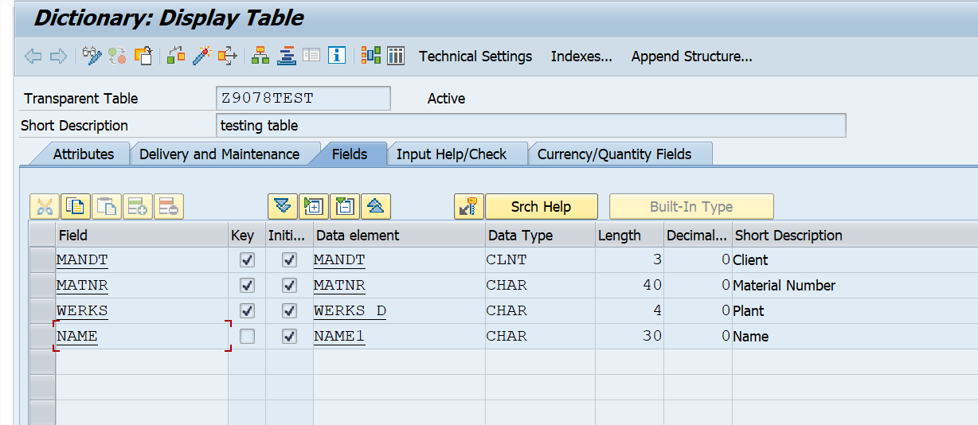

Excel

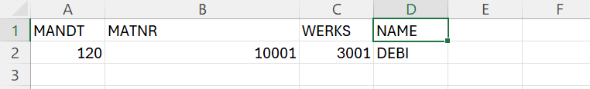

**Case 1: If Test check box is Checked.**

Input SCREEN

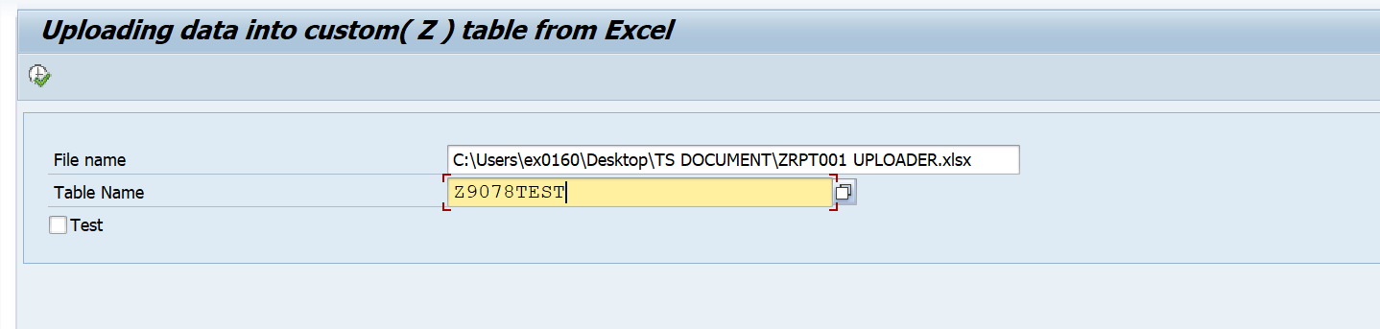

Output screen.

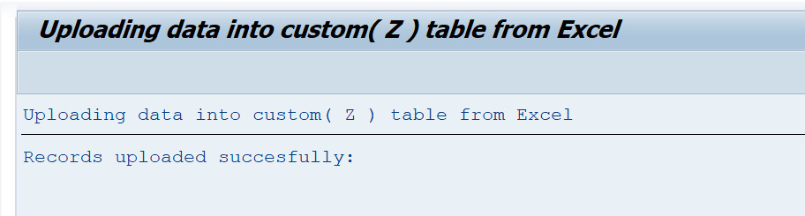

Record in Database.

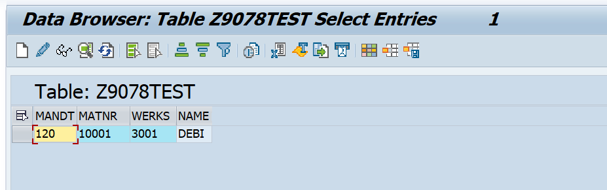

**Case 2: If Test check box is not Checked.**

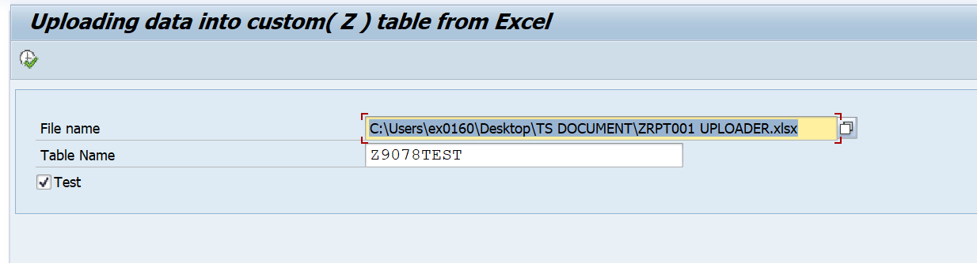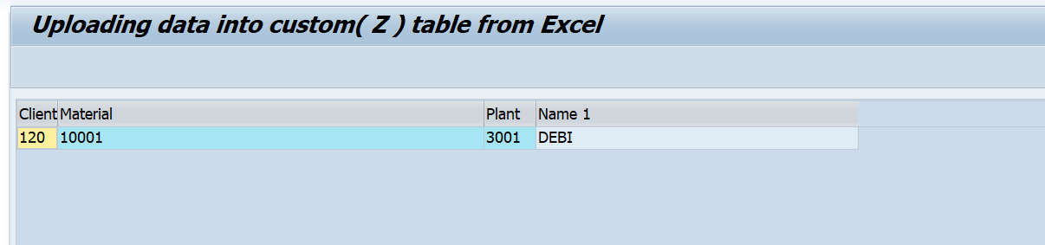

Note: **Test** Check box provided to check before upload and it’s recommended